Practical- 5: Correlation & Regression Analysis
Name: Manthan Daraji
PRN: 2020033800148223

- QUESTION - 1

Correlation: Age, Price

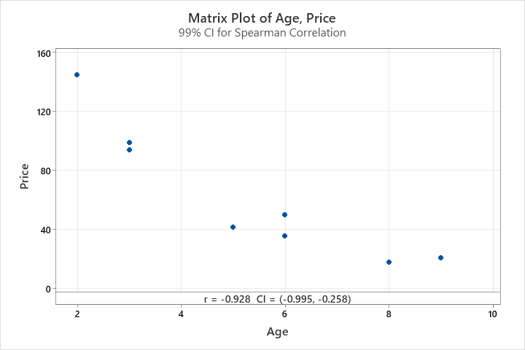

Method
Correlation type | Spearman
Number of rows used | 8
ρ: pairwise Spearman correlation

Correlations
 | Age
Price | -0.928

Pairwise Spearman Correlations
Sample 1 | Sample 2 | N | Correlation | 99% CI for ρ | P-Value
Price | Age | 8 | -0.928 | (-0.995, -0.258) | 0.001

Interpretation
Here, Correlation Coefficient (r) = -0.928. There is a negative correlation between variable Age & Price.

Hypothesis:
H0: r > 0 vs H1: r < 0
- So, here P-value (0.001) which less than alpha (0.01), Null Hypothesis rejected. We can say that there is negative correlation between Age & Price.

- 99% Confidence Interval is: (-0.995, -0.258).

- QUESTION - 2

Correlation: Height, Weight
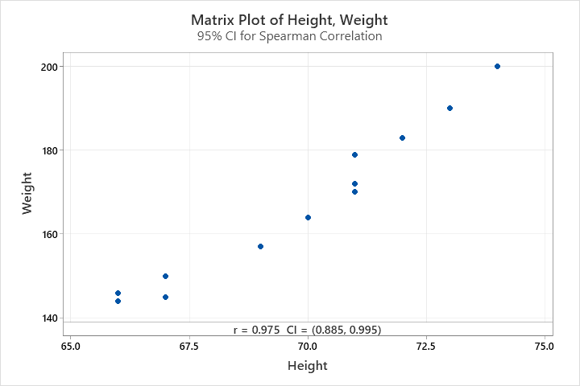

Method
Correlation type | Spearman
Number of rows used | 12
ρ: pairwise Spearman correlation

Correlations
 | Height
Weight | 0.975

Pairwise Spearman Correlations
Sample 1 | Sample 2 | N | Correlation | 95% CI for ρ | P-Value
Weight | Height | 12 | 0.975 | (0.885, 0.995) | 0.000

Interpretation

Hypothesis:
H0: r = 0.5 vs H1: r ≠ 0.5
- So, here P-value (0.000) which less than alpha (0.05), Null Hypothesis rejected. We can say that correlation between Height and weight is not a 0.5 at 5% level of significance.

- 95% Confidence Interval is: (0.885, 0.995).

- QUESTION - 3

Correlation: X_CityA, Y_CityA
Method
Correlation type | Spearman
Number of rows used | 5
ρ: pairwise Spearman correlation

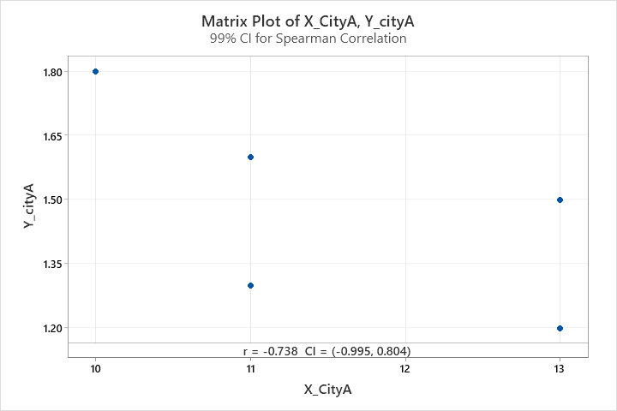

Correlations
 | X_CityA
Y_cityA | -0.738

Pairwise Spearman Correlations
Sample 1 | Sample 2 | N | Correlation | 99% CI for ρ | P-Value
Y_cityA | X_CityA | 5 | -0.738 | (-0.995, 0.804) | 0.155

Method
Correlation type | Spearman
Number of rows used | 6
ρ: pairwise Spearman correlation
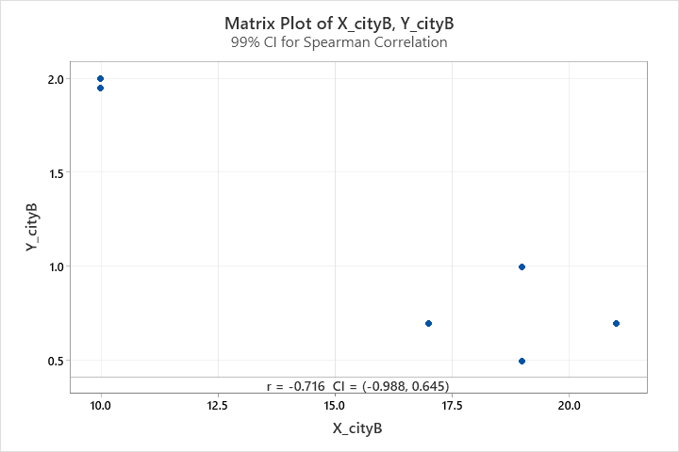

Correlations
 | X_cityB
Y_cityB | -0.716

Pairwise Spearman Correlations
Sample 1 | Sample 2 | N | Correlation | 99% CI for ρ | P-Value
Y_cityB | X_cityB | 6 | -0.716 | (-0.988, 0.645) | 0.109

Interpretation
Hypothesis:
H0: r_CityA = r_CityB vs H1: r_CityA ≠ r_CityB
- So, here P-value which greater than alpha (0.01) for both City-A and City-B, Null Hypothesis do not reject. We can say that correlation coefficient between City-A and City-B is same at 1% level of significance.

- 99% Confidence Interval for City-A: (-0.995, 0.804).
- 99% Confidence Interval for City-B: (-0.988, 0.645).

- QUESTION - 7

x1=yield of cotton
x2=no. of seed vessels
x3=height

r12= | 0.863
r13= | 0.648
r23= | 0.709
$$Multiple correlation Coefficient \left(R_{1.23}\right)= \sqrt{\frac{r_{12}^{2}+r_{13}^{2}-2r_{12}r_{13}r_{23}}{1-r_{23}^{2}}}$$

- R1.23 = 0.864519672

Partial Correlation Coefficient
$$\left(R_{12.3}\right)= \frac{r_{12}-r_{13}r_{23}}{\sqrt{\left(1-r_{13}^{2}\right)\left(1-r_{23}^{2}\right)}}$$

0.7514
$$\left(R_{13.2}\right)= \frac{r_{13}-r_{12}r_{23}}{\sqrt{\left(1-r_{12}^{2}\right)\left(1-r_{23}^{2}\right)}}$$

0.1014

- QUESTION – 9

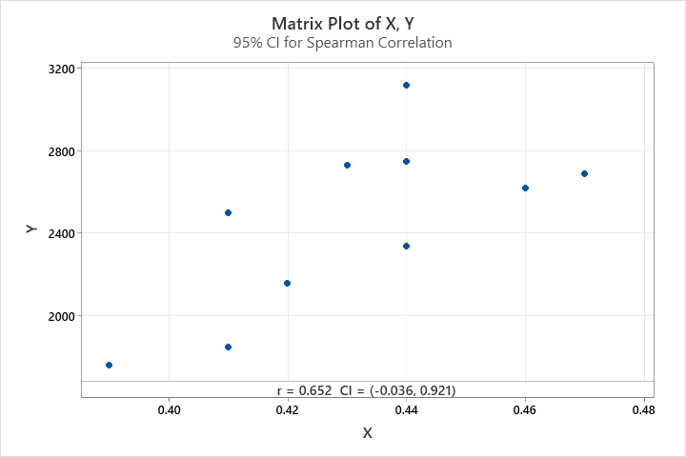

Correlation: X, Y

Method
Correlation type | Spearman
Number of rows used | 10
ρ: pairwise Spearman correlation
Correlations
 | X
Y | 0.652

Pairwise Spearman Correlations
Sample 1 | Sample 2 | N | Correlation | 95% CI for ρ | P-Value
Y | X | 10 | 0.652 | (-0.036, 0.921) | 0.041

- Correlation Coefficient (r) = 0.652

Regression Analysis: Y versus X

Hypothesis:
H0: B1 = 0
H1: B1 ≠ 0

Regression Equation
Y | = | -2826 + 12246 X

Coefficients
Term | Coef | SE Coef | T-Value | P-Value | VIF
Constant | -2826 | 1929 | -1.46 | 0.181
X | 12246 | 4469 | 2.74 | 0.025 | 1.00

Model Summary
S | R-sq | R-sq(adj) | R-sq(pred)
325.054 | 48.41% | 41.96% | 21.70%

Analysis of Variance
Source | DF | Adj SS | Adj MS | F-Value | P-Value
Regression | 1 | 793279 | 793279 | 7.51 | 0.025
X | 1 | 793279 | 793279 | 7.51 | 0.025
Error | 8 | 845281 | 105660
Lack-of-Fit | 5 | 329564 | 65913 | 0.38 | 0.836
Pure Error | 3 | 515717 | 171906
Total | 9 | 1638560

- Regression Equation, Y = -2826 + 12246*X
Y-cap =2439.78

- QUESTION – 8

- Scatterplot of Y vs X

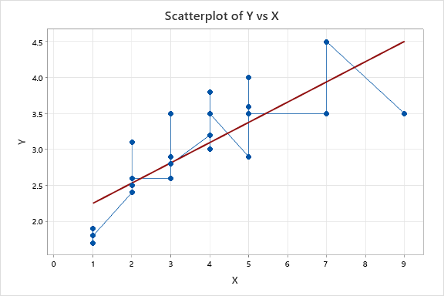

Regression Equation
Y | = | 1.971 + 0.2814 X

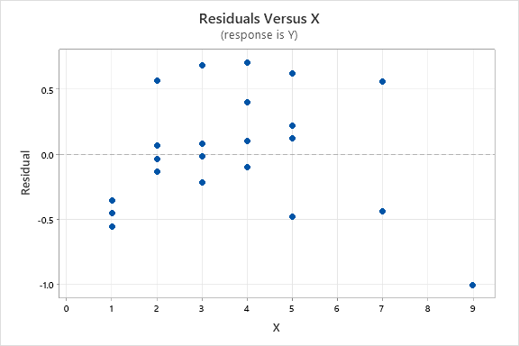

- Outlier Test: X, Y

Method
Null hypothesis | All data values come from the same normal population
Alternative hypothesis | Largest data value is an outlier
Significance level | α = 0.05

Grubbs' Test
Variable | N | Mean | StDev | Min | Max | G | P
X | 25 | 2.984 | 0.725 | 1.700 | 4.500 | 2.09 | 0.369
Y | 25 | 3.600 | 2.041 | 1.000 | 9.000 | 2.65 | 0.054

